Vacancy Report

October 2025

Released 12 November 2025

Job ads up 0.2% nationally in October
This month’s report shows the period of record growth in advertisements following the COVID-19 pandemic is ending, with vacancy numbers having decreased in 7 of the past 12 months. Despite this, vacancy numbers remain at elevated levels, with around 21% more advertisements in the labour market presently than compared with the monthly average for 2019.
- Online job advertisements at the national level increased in October 2025 (up by 0.2% or 350) to stand at 208,000.
  - Over the year to October 2025, online job advertisements decreased by 7.3% (or 16,500). Vacancy numbers, though, are at high levels historically.
  - This downward trend is present in other demand indicators, with the Australian Bureau of Statistics’ Job Vacancies, Australia series showing a [INSERT YEARLY CHANGE (%)] increase/decrease in vacancies over the year to August 2025.
- Recruitment activity decreased across half of the states and territories over the month. The largest percentage changes were recorded in Australian Capital Territory (down by 11.2% or 560 job advertisements) followed by Northern Territory (up by 3.3% or 90) and South Australia (up by 2.2% or 290).
- Over the month, advertisements decreased across 3 Skill Level groups. The largest percentage changes were recorded for Skill Level 3 (commensurate with Certificate IV or III) occupations (up by 1.8% or 580 job advertisements) followed by Skill Level 5 (commensurate with Certificate I or secondary education) occupations (up by 1.1% or 260).
- Advertisements increased across 5 Major Occupation groups over the month. The largest percentage change was for Labourers (up by 2.0% or 280 job advertisements) followed by Machinery Operators and Drivers (up by 2.0% or 250). The smallest percentage change was recorded for Community and Personal Service Workers (down by 0.3% or 60).
- Recruitment activity was concentrated in metropolitan Australia, with 70.2% of job advertisements in October 2025 found in Australia’s capital cities. Over the last 12 months, job advertisements have decreased in regional areas (down by 4.2%); however, a larger decrease was recorded for capital cities (down by 10.6%).
Each month the IVI report provides a more detailed analysis of a particular labour market segment. This month’s report spotlights Aircraft Maintenance Engineers.

208,000
Online
Job Advertisements
(seasonally adjusted)
▲ | 0.2% | Monthly change
▼ | 7.3% | Annual change
Online job advertisements increased by 0.2% (or 350 job advertisements) in October 2025 to stand at 208,000.
Over the year to October 2025, online job advertisements decreased by 7.3% (or 16,500 job advertisements).

[HEADER FOR IVI SPOTLIGHT]
[LOREM IPSUM…]

Internet Vacancy Index Summary Sheet - October 2025
 | Number of job ads (no.) | Monthly change (no.) |  | Monthly change (%) | Annual change (no.) |  | Annual change (%)
Australia | 208,000 | 350 | ▲ | 0.2% | -16,500 | ▼ | -7.3%
New South Wales | 62,400 | 760 | ▲ | 1.2% | -2,700 | ▼ | -4.2%
Victoria | 45,500 | -170 | ▼ | -0.4% | -5,400 | ▼ | -10.6%
Queensland | 49,800 | 290 | ▲ | 0.6% | -4,600 | ▼ | -8.5%
South Australia | 13,900 | 290 | ▲ | 2.2% | -30 | ▼ | -0.2%
Western Australia | 25,800 | -260 | ▼ | -1.0% | -2,000 | ▼ | -7.1%
Tasmania | 3,300 | -10 | ▼ | -0.3% | -400 | ▼ | -10.8%
Northern Territory | 2,900 | 90 | ▲ | 3.3% | -290 | ▼ | -9.0%
Australian Capital Territory | 4,400 | -560 | ▼ | -11.2% | -1,500 | ▼ | -24.8%

Managers | 24,500 | 160 | ▲ | 0.7% | -1,900 | ▼ | -7.3%
Professionals | 59,000 | -750 | ▼ | -1.3% | -5,200 | ▼ | -8.0%
Technicians and Trades Workers | 29,800 | 550 | ▲ | 1.9% | -2,400 | ▼ | -7.4%
Community and Personal Service Workers | 20,500 | -60 | ▼ | -0.3% | -3,200 | ▼ | -13.6%
Clerical and Administrative Workers | 31,100 | -120 | ▼ | -0.4% | -2,800 | ▼ | -8.3%
Sales Workers | 16,300 | 70 | ▲ | 0.4% | -1,200 | ▼ | -6.6%
Machinery Operators and Drivers | 12,700 | 250 | ▲ | 2.0% | 380 | ▲ | 3.1%
Labourers | 14,100 | 280 | ▲ | 2.0% | -110 | ▼ | -0.8%

Skill Level 1 - Bachelor degree or higher | 75,700 | -680 | ▼ | -0.9% | -6,400 | ▼ | -7.8%
Skill Level 2 - Advanced Diploma or Diploma | 23,400 | -150 | ▼ | -0.6% | -2,600 | ▼ | -9.9%
Skill Level 3 - Certificate IV or III* (Skilled VET) | 32,900 | 580 | ▲ | 1.8% | -2,400 | ▼ | -6.7%
Skill Level 4 - Certificate II or III | 52,600 | -60 | ▼ | -0.1% | -4,000 | ▼ | -7.1%
Skill Level 5 - Certificate I or secondary education | 23,400 | 260 | ▲ | 1.1% | -1,100 | ▼ | -4.5%
*Includes at least two years of on-the-job training.
Source: Jobs and Skills Australia, Internet Vacancy Index, seasonally adjusted data, October 2025.

Line graph showing trends in employment and job advertisements. From January 2006 to October 2025. Vacancies peaked in April 2008 which represents the pre-GFC peak recruitment activity. Vacancies rose again in March 2011, which was the mining boom peak recruitment. Vacancies and employment experienced a downturn in April 2020 due to the COVID-19 pandemic, although both employment and job advertisements have recovered and are presently at record levels.
Figure 1: Job advertisements and unemployment rate, January 2006 to October 2025
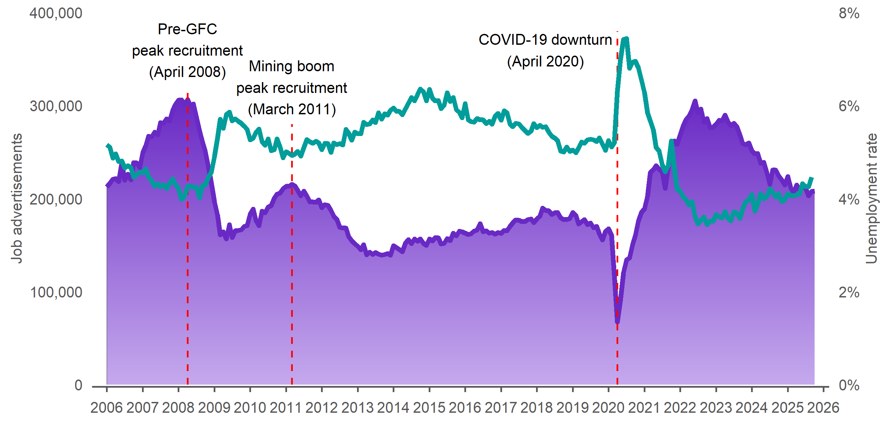
Source: Australian Bureau of Statistics, Labour Force, Australia, seasonally adjusted data, September 2025; Jobs and Skills Australia, Internet Vacancy Index, seasonally adjusted data, October 2025.

The next IVI release is scheduled for 10 December 2025. The IVI is published on the JSA website at jobsandskills.gov.au/data/internet-vacancy-index.

The Internet Vacancy Index (IVI) is a monthly data series measuring online job advertisements, compiled by Jobs and Skills Australia (JSA). The IVI counts job advertisements newly lodged on the SEEK, CareerOne and Workforce Australia online job boards. Commencing in 2006, the IVI is the longest continuous time series for vacancy data in Australia. JSA research indicates the proportion of all vacancies covered by IVI has increased from 38% in 2016 to 57% in 2024. More detail on the IVI is available at jobsandskills.gov.au/data/internet-vacancy-index.


Australian Bureau of Statistics (ABS), ‘Job Vacancies, Australia’, seasonally adjusted data, August 2025.

